Bahria University,

Karachi Campus



LAB EXPERIMENT NO.

**06**

LIST OF TASKS

|  |  |
| --- | --- |
| TASK NO | OBJECTIVE |
| **1** | **Create a web service of online add to cart system.** |
| 2 | Create calculator Web Service |

**Task 1: Create a web service of online add to cart system.**

**Solution:**

[WebMethod]

public string Cart(string addingItem,string item)

{

addingItem=item;

return Get(addingItem);

}

[WebMethod]

public string Get(string item)

{

return item;

}

**Output:**

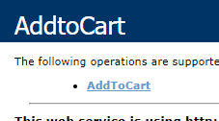

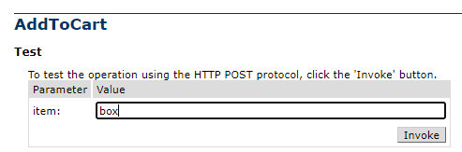

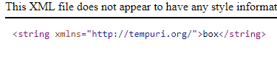

**Task 2: Create calculator Web Service.**

**Solution:**

public class Calculator : System.Web.Services.WebService

{

[WebMethod]

public string Addition(int a, int b)

{

return (a + b).ToString();

}

[WebMethod]

public string Subtraction(int a, int b)

{

return (a - b).ToString();

}

[WebMethod]

public string Multiplication(int a, int b)

{

return (a * b).ToString(); }

[WebMethod]

public string Division(double a, double b)

{

return (a / b).ToString();

}

}

**Output:**

